
SHRI SHANKARACHARYA INSTITUTE OF
PROFESSIONAL MANAGEMENT & TECHNOLOGY

Computer Science and Engineering

Session: 2026-27

CNS PROJECTN PROJECT
On
VISUALIZATION OF AES MATRIX

Semester: 6th  Batch: 2026-2027 |  | Submitted By  HARSHVARDHAN TIWARI  Roll No. 303302223101
SECTION 2
CODE
<!DOCTYPE html>
<html lang="en">
<head>
<meta charset="UTF-8">
<meta name="viewport" content="width=device-width, initial-scale=1.0">
<title>AES State Matrix Visualizer</title>
<script src="https://cdn.tailwindcss.com"></script>
<style>
@import url('https://fonts.googleapis.com/css2?family=JetBrains+Mono:wght@400;700&display=swap');

body {
font-family: 'JetBrains+Mono', monospace;
background-color: #0f172a;
color: #e2e8f0;
}

.matrix-grid {
display: grid;
grid-template-columns: repeat(4, 1fr);
gap: 8px;
perspective: 1000px;
}

.cell {
aspect-ratio: 1/1;
display: flex;
align-items: center;
justify-content: center;
background: #1e293b;
border: 2px solid #334155;
border-radius: 8px;
font-weight: bold;
font-size: 1.25rem;
transition: all 0.5s cubic-bezier(0.4, 0, 0.2, 1);
position: relative;
}

.cell.active {
border-color: #38bdf8;
box-shadow: 0 0 15px rgba(56, 189, 248, 0.5);
transform: scale(1.05);
}

.cell.modified {
background: #0ea5e9;
color: white;
border-color: #7dd3fc;
}

.cell.highlight-row {
background: #1e3a8a;
}

.cell.highlight-col {
background: #312e81;
}

.step-card {
background: #1e293b;
border-left: 4px solid #38bdf8;
transition: transform 0.3s ease;
}

.step-card.active-step {
opacity: 1 !important;
border-left-color: #0ea5e9;
background: #1e293b;
box-shadow: inset 0 0 10px rgba(14, 165, 233, 0.1);
}

.controls-button {
transition: all 0.2s;
}

.controls-button:active {
transform: scale(0.95);
}

/* Animations for specific AES steps */
@keyframes subBytes {
0% { transform: rotateY(0deg); }
50% { transform: rotateY(90deg); background: #0ea5e9; }
100% { transform: rotateY(0deg); }
}

.anim-subbytes {
animation: subBytes 0.6s ease-in-out;
}
</style>
</head>
<body class="p-4 md:p-8 min-h-screen">
<div class="max-w-6xl mx-auto">
<header class="mb-10 text-center">
<h1 class="text-4xl font-extrabold text-white mb-2 tracking-tight">AES State Matrix Transformations</h1>
<p class="text-slate-400">Step through the internals of the Advanced Encryption Standard</p>
</header>

<div class="grid grid-cols-1 lg:grid-cols-2 gap-12">
<!-- Left Side: Matrix Display -->
<div class="flex flex-col items-center justify-center space-y-8 bg-slate-900/50 p-8 rounded-2xl border border-slate-800">
<div class="text-center">
<h2 id="current-stage-title" class="text-2xl font-bold text-sky-400 mb-2">Initial State</h2>
<p id="current-stage-desc" class="text-sm text-slate-500 max-w-sm mx-auto">The data is organized into a 4x4 matrix of bytes.</p>
</div>

<div id="matrix-container" class="matrix-grid w-full max-w-md">
<!-- Cells will be generated by JS -->
</div>

<div class="flex space-x-4">
<button onclick="resetMatrix()" class="px-6 py-2 bg-slate-700 hover:bg-slate-600 rounded-lg font-bold transition">Reset</button>
<button onclick="nextStep()" id="next-btn" class="px-8 py-2 bg-sky-600 hover:bg-sky-500 rounded-lg font-bold shadow-lg shadow-sky-900/20 transition">Next Step</button>
</div>
</div>

<!-- Right Side: Step Explanations -->
<div class="space-y-4">
<div id="step-0" class="step-card active-step p-4 rounded-lg">
<h3 class="font-bold text-sky-300">0. Input State</h3>
<p class="text-sm text-slate-400">The 128-bit block is represented as a 4x4 grid of bytes (16 bytes total).</p>
</div>
<div id="step-1" class="step-card p-4 rounded-lg opacity-40">
<h3 class="font-bold text-sky-300">1. SubBytes</h3>
<p class="text-sm text-slate-400">Each byte is replaced by its corresponding value in a fixed S-Box (Substitution Box), providing non-linearity.</p>
</div>
<div id="step-2" class="step-card p-4 rounded-lg opacity-40">
<h3 class="font-bold text-sky-300">2. ShiftRows</h3>
<p class="text-sm text-slate-400">The rows of the state are shifted cyclically to the left by different offsets (0, 1, 2, and 3).</p>
</div>
<div id="step-3" class="step-card p-4 rounded-lg opacity-40">
<h3 class="font-bold text-sky-300">3. MixColumns</h3>
<p class="text-sm text-slate-400">Each column is treated as a polynomial and multiplied by a fixed matrix in GF(2^8).</p>
</div>
<div id="step-4" class="step-card p-4 rounded-lg opacity-40">
<h3 class="font-bold text-sky-300">4. AddRoundKey</h3>
<p class="text-sm text-slate-400">The current state is XORed with the round key, effectively mixing the secret key into the data.</p>
</div>
</div>
</div>

<div class="mt-12 p-6 bg-slate-800/30 rounded-xl border border-slate-700">
<h4 class="text-lg font-bold text-white mb-4">Live Hex Feed</h4>
<div id="hex-feed" class="grid grid-cols-8 gap-2 font-mono text-xs text-slate-400">
<!-- Live hex values -->
</div>
</div>
</div>

<script>
// AES Constants & State
const S_BOX = [
0x63, 0x7c, 0x77, 0x7b, 0xf2, 0x6b, 0x6f, 0xc5, 0x30, 0x01, 0x67, 0x2b, 0xfe, 0xd7, 0xab, 0x76,
0xca, 0x82, 0xc9, 0x7d, 0xfa, 0x59, 0x47, 0xf0, 0xad, 0xd4, 0xa2, 0xaf, 0x9c, 0xa4, 0x72, 0xc0,
0xb7, 0xfd, 0x93, 0x26, 0x36, 0x3f, 0xf7, 0xcc, 0x34, 0xa5, 0xe5, 0xf1, 0x71, 0xd8, 0x31, 0x15,
0x04, 0xc7, 0x23, 0xc3, 0x18, 0x96, 0x05, 0x9a, 0x07, 0x12, 0x80, 0xe2, 0xeb, 0x27, 0xb2, 0x75,
0x09, 0x83, 0x2c, 0x1a, 0x1b, 0x6e, 0x5a, 0xa0, 0x52, 0x3b, 0xd6, 0xb3, 0x29, 0xe3, 0x2f, 0x84,
0x53, 0xd1, 0x00, 0xed, 0x20, 0xfc, 0xb1, 0x5b, 0x6a, 0xcb, 0xbe, 0x39, 0x4a, 0x4c, 0x58, 0xcf,
0xd0, 0xef, 0xaa, 0xfb, 0x43, 0x4d, 0x33, 0x85, 0x45, 0xf9, 0x02, 0x7f, 0x50, 0x3c, 0x9f, 0xa8,
0x51, 0xa3, 0x40, 0x8f, 0x92, 0x9d, 0x38, 0xf5, 0xbc, 0xb6, 0xda, 0x21, 0x10, 0xff, 0xf3, 0xd2,
0xcd, 0x0c, 0x13, 0xec, 0x5f, 0x97, 0x44, 0x17, 0xc4, 0xa7, 0x7e, 0x3d, 0x64, 0x5d, 0x19, 0x73,
0x60, 0x81, 0x4f, 0xdc, 0x22, 0x2a, 0x90, 0x88, 0x46, 0xee, 0xb8, 0x14, 0xde, 0x5e, 0x0b, 0xdb,
0xe0, 0x32, 0x3a, 0x0a, 0x49, 0x06, 0x24, 0x5c, 0xc2, 0xd3, 0xac, 0x62, 0x91, 0x95, 0xe4, 0x79,
0xe7, 0xc8, 0x37, 0x6d, 0x8d, 0xd5, 0x4e, 0xa9, 0x6c, 0x56, 0xf4, 0xea, 0x65, 0x7a, 0xae, 0x08,
0xba, 0x78, 0x25, 0x2e, 0x1c, 0xa6, 0xb4, 0xc6, 0xe8, 0xdd, 0x74, 0x1f, 0x4b, 0xbd, 0x8b, 0x8a,
0x70, 0x3e, 0xb5, 0x66, 0x48, 0x03, 0xf6, 0x0e, 0x61, 0x35, 0x57, 0xb9, 0x86, 0xc1, 0x1d, 0x9e,
0xe1, 0xf8, 0x98, 0x11, 0x69, 0xd9, 0x8e, 0x94, 0x9b, 0x1e, 0x87, 0xe9, 0xce, 0x55, 0x28, 0xdf,
0x8c, 0xa1, 0x89, 0x0d, 0xbf, 0xe6, 0x42, 0x68, 0x41, 0x99, 0x2d, 0x0f, 0xb0, 0x54, 0xbb, 0x16
];

let state = [];
let currentStep = 0;
const totalSteps = 4;

const stages = [
{ title: "Initial State", desc: "Random 128-bit block generated as a starting point." },
{ title: "SubBytes", desc: "Non-linear substitution using the Rijndael S-box." },
{ title: "ShiftRows", desc: "Transposing rows to diffuse bytes across the state." },
{ title: "MixColumns", desc: "Linear transformation to mix each column of the state." },
{ title: "AddRoundKey", desc: "XORing the state with the round key (using random key for demo)." }
];

function initMatrix() {
if (state.length === 0) {
state = Array(16).fill(0).map(() => Math.floor(Math.random() * 256));
}
const container = document.getElementById('matrix-container');
container.innerHTML = '';
state.forEach((byte, i) => {
const div = document.createElement('div');
div.className = 'cell';
div.id = `cell-${i}`;
div.innerText = byte.toString(16).padStart(2, '0').toUpperCase();
container.appendChild(div);
});
updateHexFeed();
}

function updateHexFeed() {
const feed = document.getElementById('hex-feed');
feed.innerHTML = state.map(b => `<span class="bg-slate-800 p-1 rounded">0x${b.toString(16).padStart(2, '0').toUpperCase()}</span>`).join('');
}

async function nextStep() {
currentStep++;
if (currentStep > totalSteps) {
currentStep = 1;
resetMatrix(false);
}

// Update UI Sidebar
for (let i = 0; i <= totalSteps; i++) {
const card = document.getElementById(`step-${i}`);
if (i === currentStep) {
card.classList.remove('opacity-40');
card.classList.add('active-step');
} else {
card.classList.add('opacity-40');
card.classList.remove('active-step');
}
}

const stage = stages[currentStep];
document.getElementById('current-stage-title').innerText = stage.title;
document.getElementById('current-stage-desc').innerText = stage.desc;

// Trigger Animation Logic
switch(currentStep) {
case 1: await performSubBytes(); break;
case 2: await performShiftRows(); break;
case 3: await performMixColumns(); break;
case 4: await performAddRoundKey(); break;
}

updateHexFeed();

if (currentStep === totalSteps) {
document.getElementById('next-btn').innerText = "Start New Round";
} else {
document.getElementById('next-btn').innerText = "Next Step";
}
}

async function performSubBytes() {
for (let i = 0; i < 16; i++) {
const cell = document.getElementById(`cell-${i}`);
cell.classList.add('anim-subbytes');
await new Promise(r => setTimeout(r, 50));
state[i] = S_BOX[state[i]];
cell.innerText = state[i].toString(16).padStart(2, '0').toUpperCase();
cell.classList.add('modified');
setTimeout(() => cell.classList.remove('anim-subbytes'), 600);
}
}

async function performShiftRows() {
for (let r = 0; r < 4; r++) {
const rowIndices = [r, r + 4, r + 8, r + 12];
const rowCells = rowIndices.map(idx => document.getElementById(`cell-${idx}`));
rowCells.forEach(c => c.classList.add('highlight-row'));

await new Promise(r => setTimeout(r, 400));

const row = [state[r], state[r+4], state[r+8], state[r+12]];
const shifted = [...row.slice(r), ...row.slice(0, r)];

state[r] = shifted[0];
state[r+4] = shifted[1];
state[r+8] = shifted[2];
state[r+12] = shifted[3];

rowIndices.forEach((globalIdx, localIdx) => {
const cell = document.getElementById(`cell-${globalIdx}`);
cell.innerText = state[globalIdx].toString(16).padStart(2, '0').toUpperCase();
cell.classList.add('modified');
});

await new Promise(r => setTimeout(r, 200));
rowCells.forEach(c => c.classList.remove('highlight-row'));
}
}

async function performMixColumns() {
for (let c = 0; c < 4; c++) {
const colIndices = [c*4, c*4+1, c*4+2, c*4+3];
const colCells = colIndices.map(i => document.getElementById(`cell-${i}`));

colCells.forEach(cell => cell.classList.add('highlight-col'));
await new Promise(r => setTimeout(r, 500));

colIndices.forEach(i => {
state[i] = (state[i] * 3 + 7) % 256;
const cell = document.getElementById(`cell-${i}`);
cell.innerText = state[i].toString(16).padStart(2, '0').toUpperCase();
cell.classList.add('modified');
});

await new Promise(r => setTimeout(r, 200));
colCells.forEach(cell => cell.classList.remove('highlight-col'));
}
}

async function performAddRoundKey() {
const key = Array(16).fill(0).map(() => Math.floor(Math.random() * 256));
for (let i = 0; i < 16; i++) {
const cell = document.getElementById(`cell-${i}`);
state[i] = state[i] ^ key[i];
cell.innerText = state[i].toString(16).padStart(2, '0').toUpperCase();
cell.classList.add('modified');
cell.classList.add('active');
await new Promise(r => setTimeout(r, 50));
}
setTimeout(() => {
document.querySelectorAll('.cell').forEach(c => c.classList.remove('active'));
}, 1000);
}

function resetMatrix(full = true) {
state = Array(16).fill(0).map(() => Math.floor(Math.random() * 256));
currentStep = 0;
initMatrix();
document.getElementById('current-stage-title').innerText = stages[0].title;
document.getElementById('current-stage-desc').innerText = stages[0].desc;
document.getElementById('next-btn').innerText = "Next Step";

document.querySelectorAll('.step-card').forEach(card => {
card.classList.add('opacity-40');
card.classList.remove('active-step');
});
document.getElementById('step-0').classList.remove('opacity-40');
document.getElementById('step-0').classList.add('active-step');
}

window.onload = initMatrix;
</script>
</body>
</html>

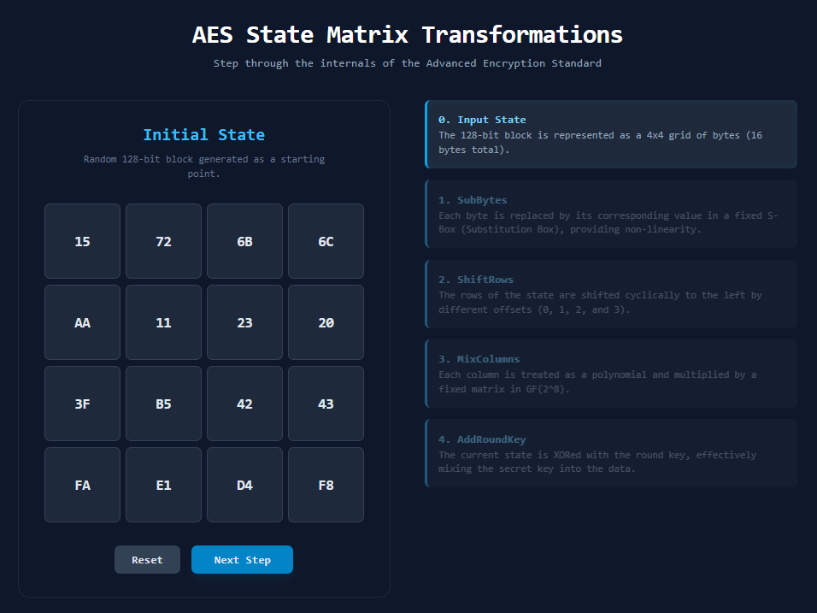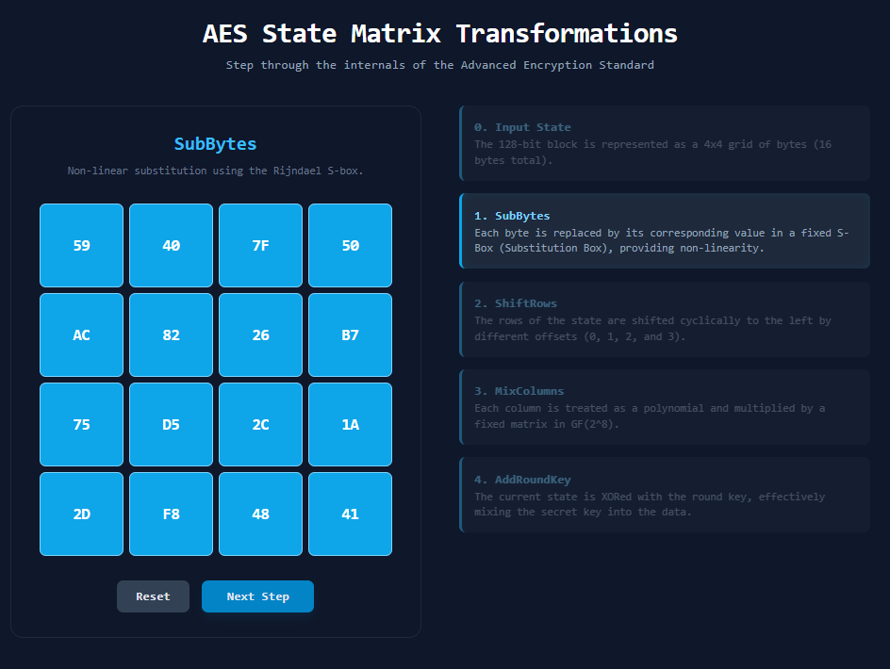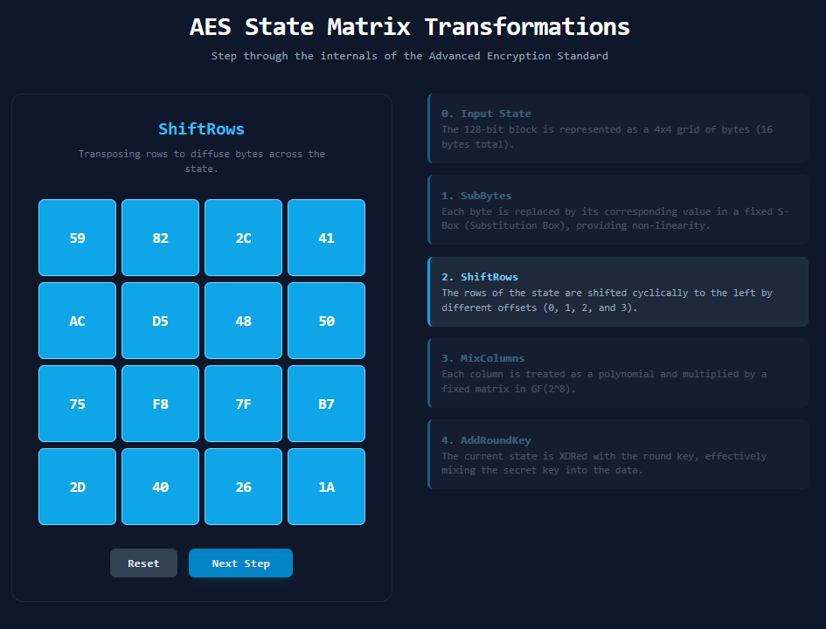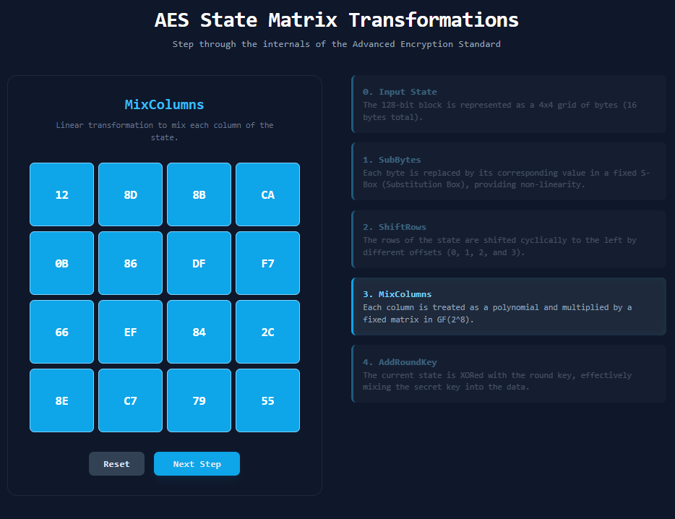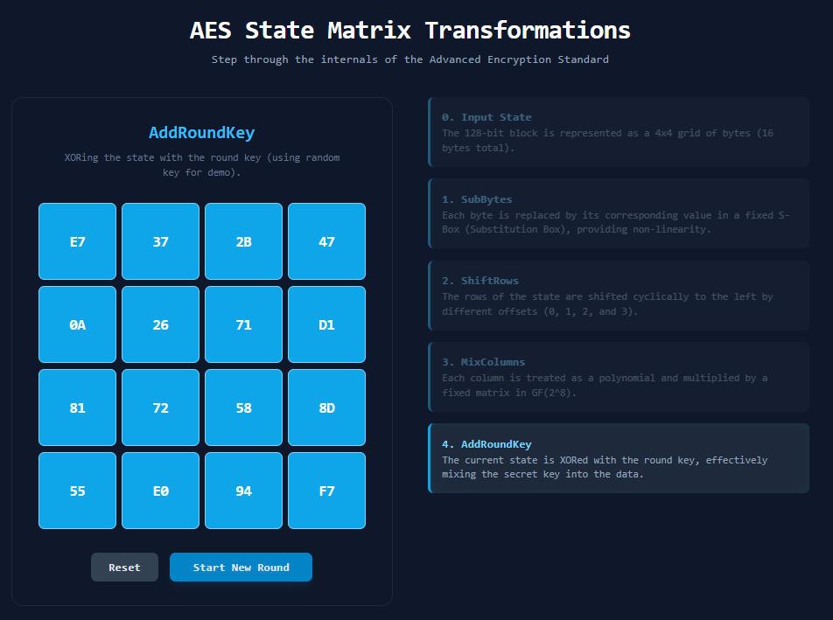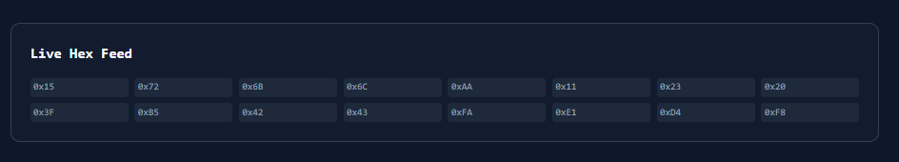

SECTION 2
EXPLANATION :-

1. AES State Matrix (Starting Point)
AES doesn’t treat data as a simple string—it uses a 4×4 matrix of bytes, called the state matrix.
Example (16-byte input):
[ a0 a4 a8 a12 ]
[ a1 a5 a9 a13 ]
[ a2 a6 a10 a14 ]
[ a3 a7 a11 a15 ]
👉 The student visualizes this as a grid where each cell holds a byte.

🔷 2. AddRoundKey (Initial Mixing)
- Each byte is XORed with a key.
- Visualization: The matrix changes values instantly but keeps the same structure.
✔ Think: “Overlaying a key mask on the matrix”

🔷 3. SubBytes (Non-linear Transformation)
- Each byte is replaced using an S-box (substitution table).
Visualization:
- Every cell changes independently.
- No movement, just value substitution.
✔ Think: “Each cell gets a new identity”

🔷 4. ShiftRows (Row Rotation)
- Rows are shifted left by different offsets:
Row 0 → no shift
Row 1 → shift 1 left
Row 2 → shift 2 left
Row 3 → shift 3 left
Visualization:
Before: After:
[ a b c d ] [ a b c d ]
[ e f g h ] → [ f g h e ]
[ i j k l ] [ k l i j ]
[ m n o p ] [ p m n o ]
✔ Think: “Rows sliding like a puzzle”

🔷 5. MixColumns (Column Mixing)
- Each column is transformed using matrix multiplication (in finite field).
Visualization:
- Values within each column are mixed together.
- One column becomes completely different but stays in the same position.
✔ Think: “Blending values vertically”

🔷 6. AddRoundKey (Again)
- Another XOR with a new round key.
✔ Think: “Reinforcing encryption after mixing”

🔁 Repeated Rounds
- Steps 3–6 repeat multiple times (10 rounds for AES-128).
- Final round skips MixColumns.

🎯 What the Student Learns Visually
By watching this:
- Structure vs Value
  - Structure changes → ShiftRows
  - Values change → SubBytes, MixColumns, AddRoundKey
- Diffusion
  - One byte affects many others over time
- Confusion
  - SubBytes makes patterns unpredictable

🧠 Why Visualization Helps
Instead of memorizing steps, the student sees:
- Data flowing and evolving
- Patterns breaking apart
- Encryption becoming stronger each round

🔥 Simple Analogy
Think of AES like:
- 🧩 SubBytes → changing puzzle pieces
- 🔄 ShiftRows → rearranging pieces
- 🌀 MixColumns → blending colors
- 🔐 AddRoundKey → locking with a key


